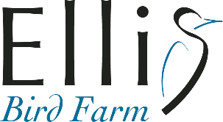 Volunteer Application Form
Name: |  |  | Phone Number:
Email Address: |  |  | Mailing Address:
Date of Application:
Please check which areas of interest you would like to volunteer in below.
Breeding Bird Nest Checks & Data Collection |  |  |  | ☐
Bat Counts |  |  |  | ☐
Bird Counts (bird identification skill required) |  |  |  | ☐
Bird Banding |  |  |  | ☐
Gardening (weeding, watering, mulching etc.) |  |  |  | ☐
General Labour (cleaning, painting, trail maintenance etc.) |  |  |  | ☐
Data Entry (basic computer skills required) |  |  |  | ☐
School/Kids Programs |  |  |  | ☐
Events (operating info tables, speaking with public, facepainting, crafts with kids etc.) |  |  |  | ☐
Farm Labour |  |  |  | ☐
Website |  |  |  | ☐
Farmer’s Markets (operate a table on behalf of Ellis Bird Farm) |  |  |  | ☐
Other (please make a suggestion):
Why do you want to volunteer at Ellis Bird Farm? What type of experience would you like to get?
How many hours per week can you commit? What days and times of day are you available to volunteer?
When would you like to start? (include end date if returning to school etc.)
Please include a brief work and volunteer history identifying skills that may benefit Ellis Bird Farm.
Please provide names and contact information for two references.
Return this application to info@ellisbirdfarm.ca

